|  |  |
| --- | --- |
| Student Name | Om Atul Mahadeokar |
| SRN No | 202200340 |
| Roll No | 17 |
| Program | Computer Engg. |
| Year | Third Year |
| Division | B |
| Subject | Computer Network Laboratory (BTECCE21506) |
| Assignment No | 1 |

Assignment Number - 01

**Title :** Ad-Hoc and Infrastructure Network

**Problem Statement :** Set up a small network of 2 to 4 computers using Switch. It includes installation of LAN Cards, Preparation of Cables, Assigning IP addresses and sharing C drive.

**Write information IN word document related to following computer network terms with diagram.**

1. **NIC Card**
2. **Hub**
3. **Switch**
4. **Network Topology**
5. **Crimping tool**
6. **LAN tester**
7. **Connector -RJ11, RJ45**
8. **Twisted pair cable – Straight through cable & Cross Over cable**

**Theory :**

1. **NIC Card (Network Interface Card)**

A Network Interface Card (NIC) is a hardware component that allows a computer to connect to a network. It can be used for both wired and wireless connections. The NIC provides the physical interface for the network, converting data from the computer into a format that can be transmitted over the network.

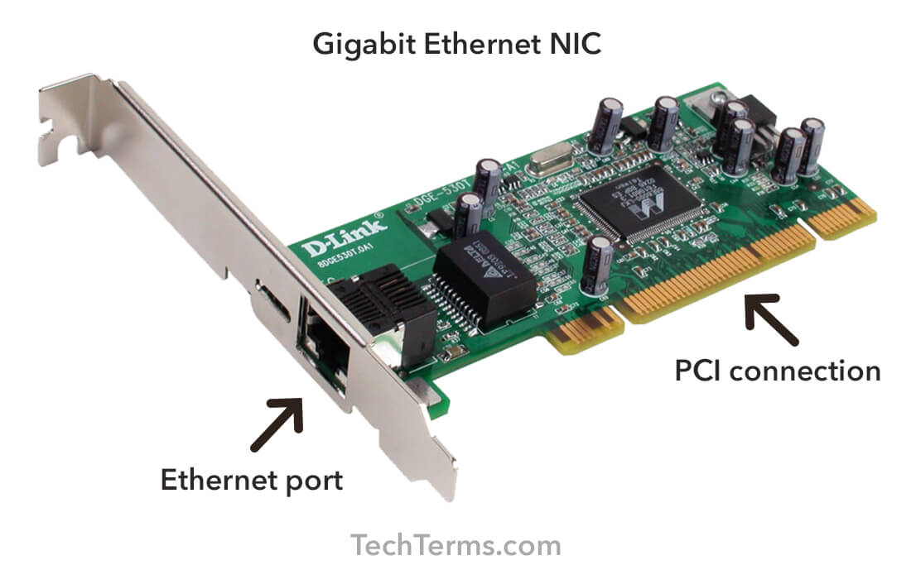

**2. Hub**

A hub is a basic networking device that connects multiple computers in a network. It operates at the physical layer of the OSI model and simply broadcasts incoming network packets to all connected devices.

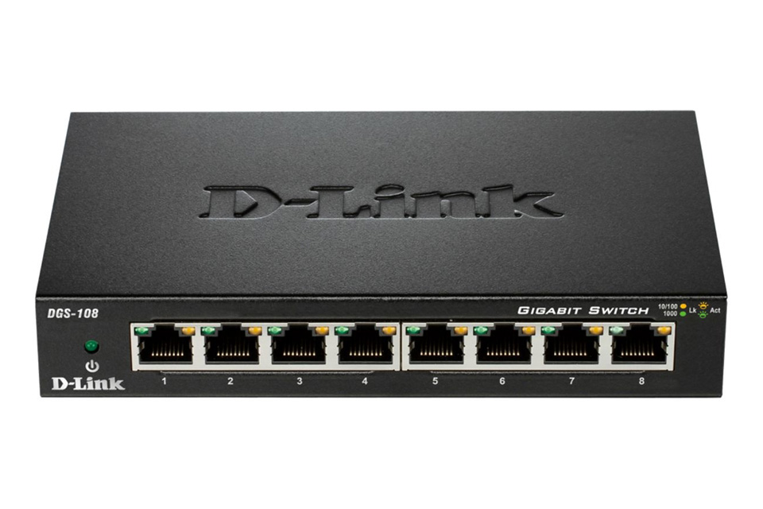

**3. Switch**

A switch is a networking device that connects multiple devices on a computer network. Unlike a hub, a switch operates at the data link layer and can filter and forward data to specific devices on the network, improving efficiency and security.

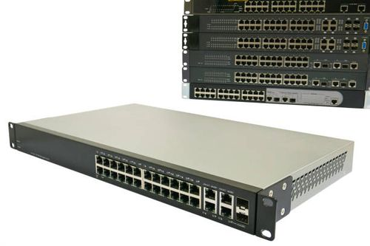

**4. Network Topology**

Network topology refers to the arrangement of different elements (links, nodes, etc.) in a computer network. Common topologies include star, ring, bus, and mesh.

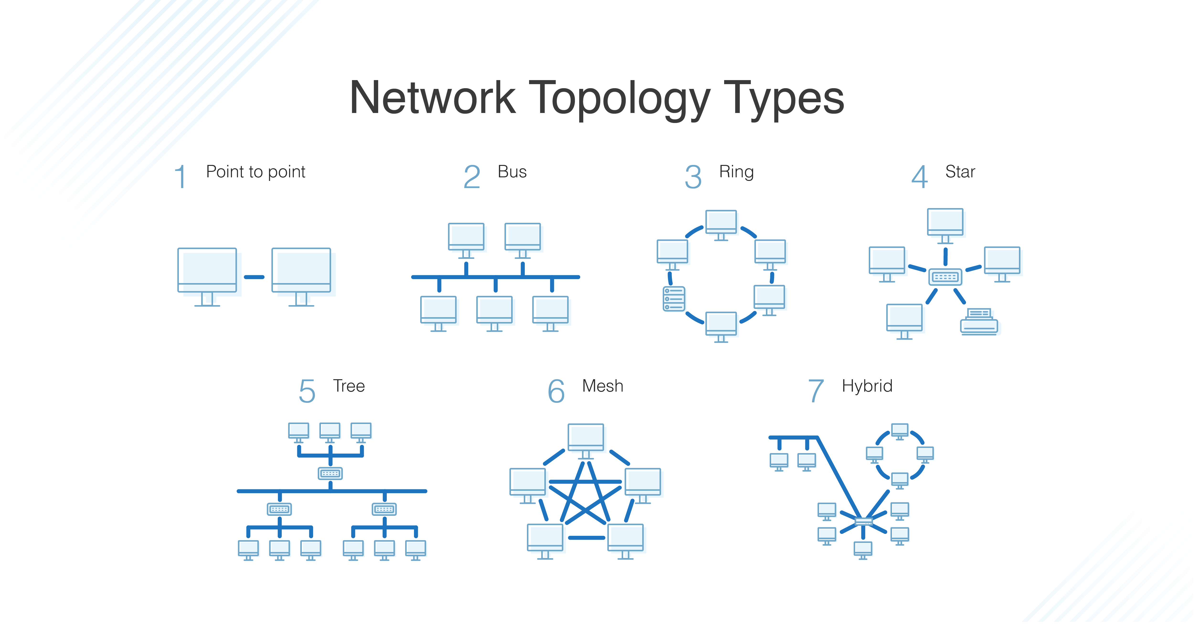

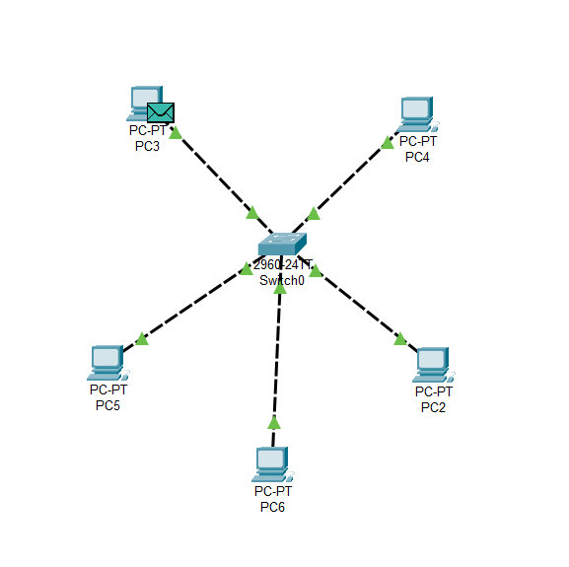

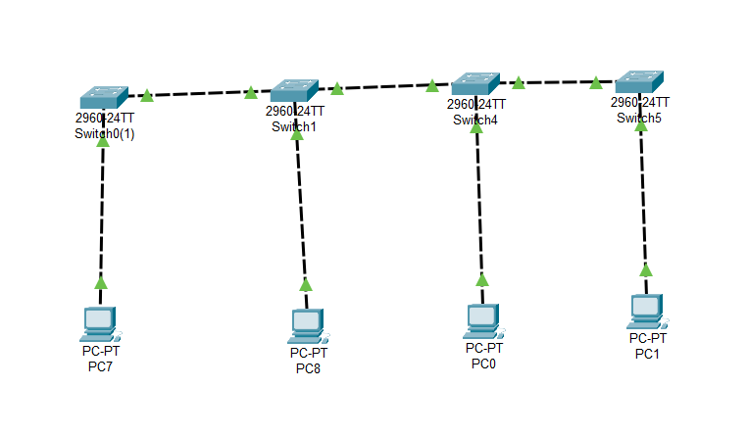

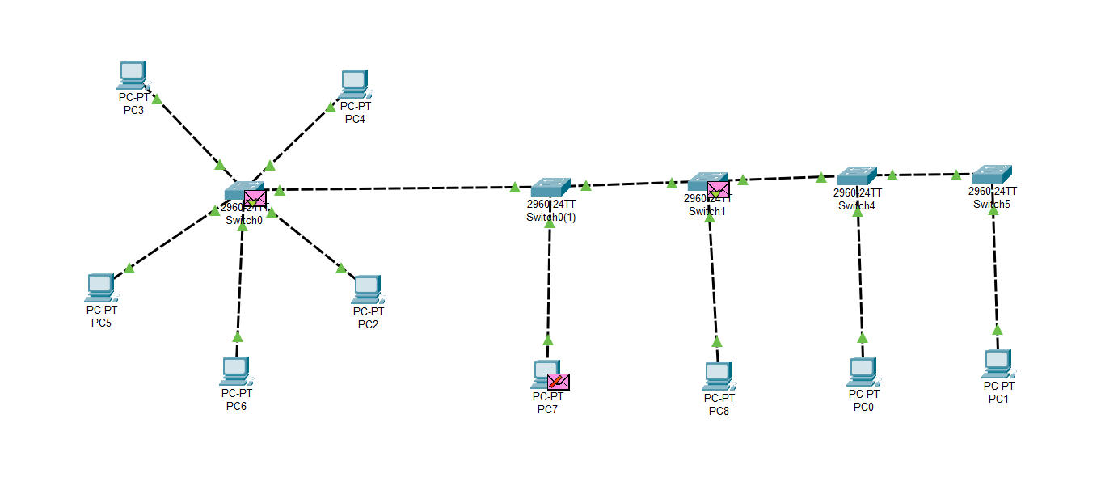

**5. Crimping Tool**

A crimping tool is used to attach connectors to the ends of cables. It is commonly used for creating custom-length network cables by attaching RJ45 connectors to twisted pair cables.



**6. LAN Tester**

A LAN tester is a device used to test the integrity and performance of network cables. It can check for continuity, signal strength, and the presence of any wiring faults.

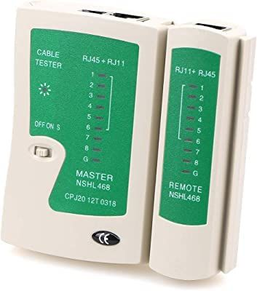

**7. Connector - RJ11, RJ45**

**RJ11**: A type of connector commonly used for telephone cables.

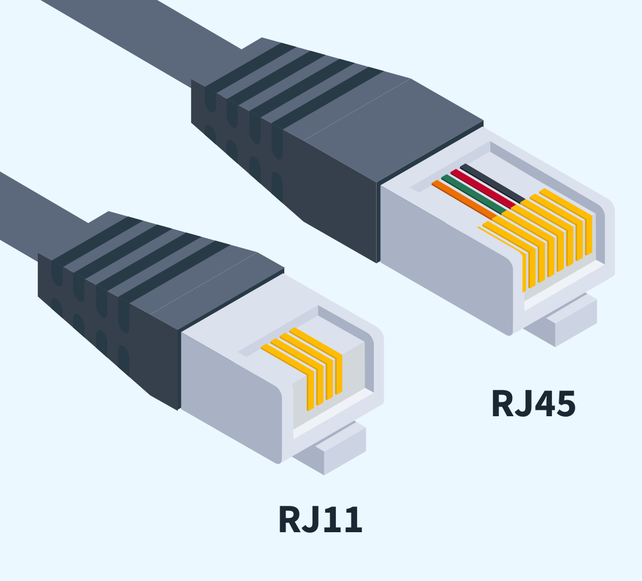

**RJ45**: A type of connector used for Ethernet networking. It is larger than RJ11 and is used with twisted pair cables.

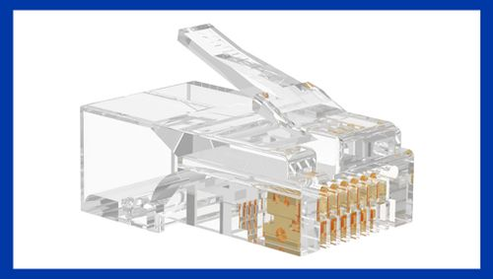

**8. Twisted Pair Cable – Straight Through Cable & Cross Over Cable**

Straight Through Cable: Used to connect different types of devices, such as a computer to a switch.

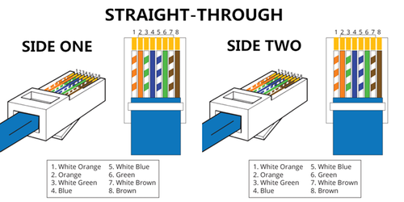

Cross Over Cable: Used to connect similar devices, such as a switch to a switch or a computer to a computer.

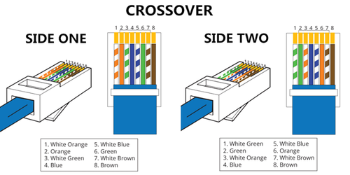

**Conclusion :**

Understanding the various components and tools used in computer networking is essential for setting up and maintaining an efficient and reliable network. NIC cards, hubs, switches, and different types of connectors and cables all play crucial roles in the functioning of a network. Tools like crimping tools and LAN testers are indispensable for network installation and troubleshooting. Knowledge of network topology helps in designing robust networks that meet specific needs. By mastering these fundamental concepts, one can effectively manage and optimize network performance.